

**HATS FOR HEROES**

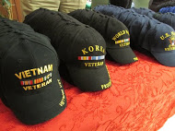

Veterans Day, November 8, 2019

Help make this Veterans Day a great day for our

US veterans who reside at the

LISVH (Long Island State Veterans Home) in Stony Brook.

Your $5 donation will purchase a hat for one of our

US veterans who reside at the LISVH.

Let’s remember our veterans and show them our appreciation for all that they have sacrificed!



Land of the Free

Because of the Brave



**UUP Community Services Committee**

**Mail/Deliver cash or check made out to “Stony Brook Foundation/LISVH” and note in Memo “Hats for Heroes program, SBF account 285040” to be received by Nov. 1st to Nancy Gaugler, c/o UUP West Campus Chapter Office, S5415 Melville Library, zip=3388**

**Any questions contact** [**Nancy.Gaugler@stonybrook.edu**](mailto:Nancy.Gaugler@stonybrook.edu) **or 632-6241.**